Instructions for members of VectorNet
on how to join the ECDC Virtual Academy (EVA)

This is a guide on the steps to take in order to: sign in; log in to EVA; and enrol as a participants of the VectorNet Ebinar series.

      - Access ECDC Virtual Academy (EVA)
Open this URL in your browser: https://eva.ecdc.europa.eu/
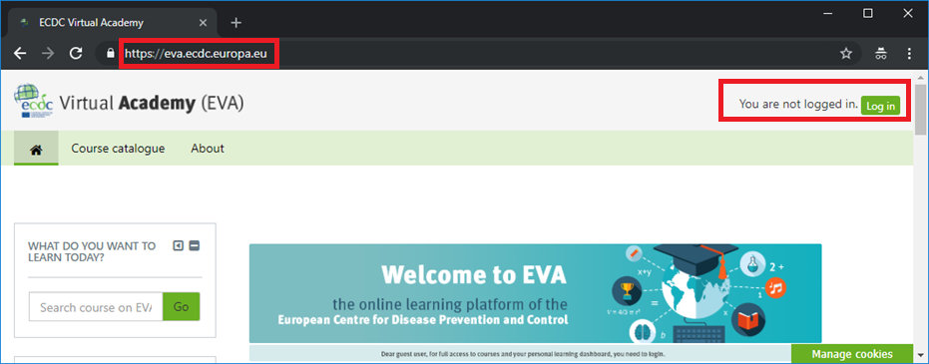

      - Authenticate using ECDC credentials
If you follow the Log in button on the right upper corner you will be taken to the ECDC Single Sign On authentication services where you are be able to authenticate using your credentials as an “external user”. The option “Internal User” is for ECDC staff.
Here is also an option to reset your password in case you do not remember it.

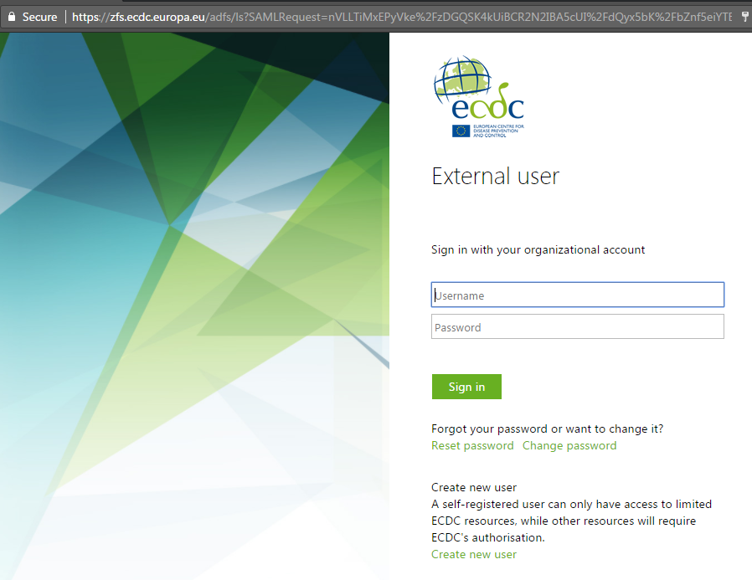
Create new account
Sign in

2.b) (Optional) In case you don’t have an ECDC account yet, pelase fill-in the form to create your account. You have to access your email box and follow the link to activate your account.
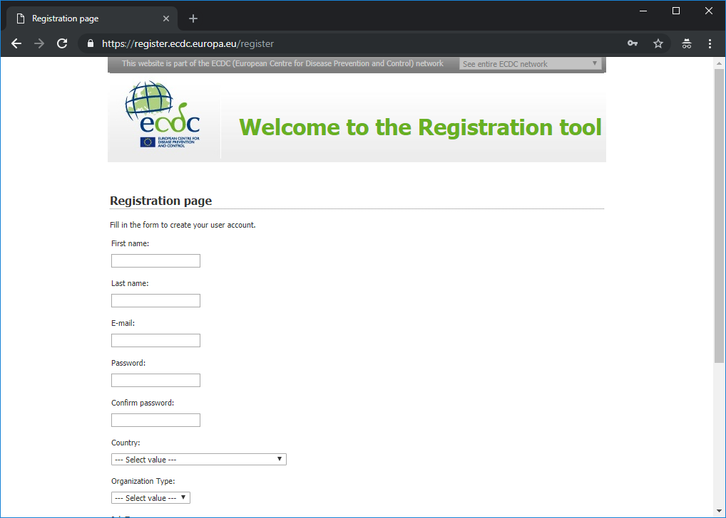
Uppon createion of a new account you will be able to authenticate in EVA (see step 2).

      - Find the activity named ‘VectorNet Webinar series’.
Upon successful authentication you will be taken to the EVA home page. Here you can find the activity. It is available under “Catalogue” -> “Open training activities” and it is named “VectorNet Webinar series”. For your convenience, use this link: https://eva.ecdc.europa.eu/course/view.php?id=298

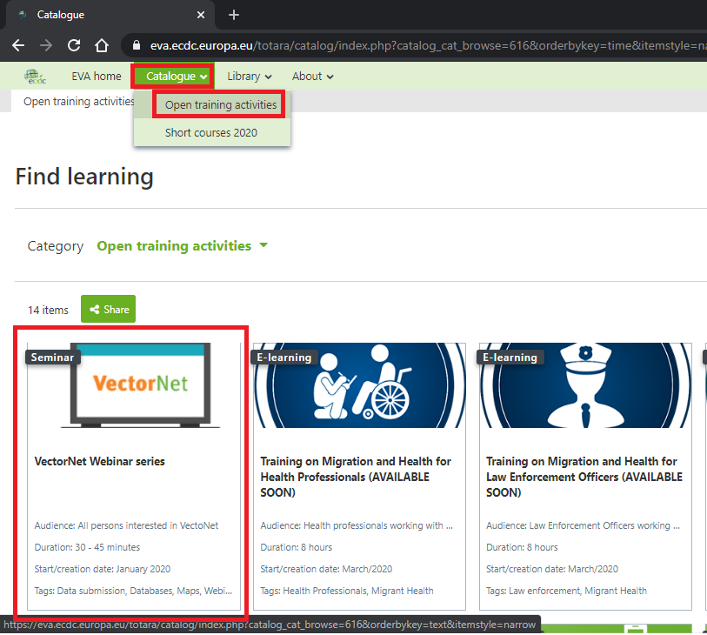

      - Self-enrol
Select the VectorNet tile from the catalogue of open training activities. You will be able to click the “enrol” button if you are successfully authenticated.
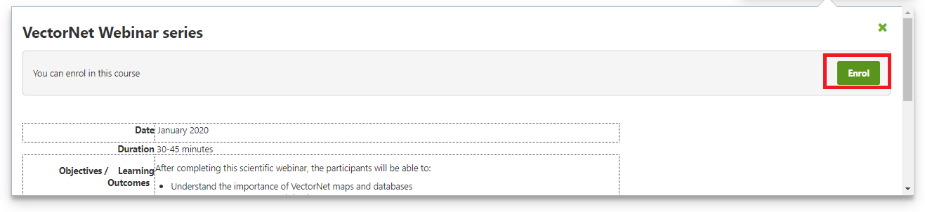
      - You are done!

You will now receve announcement of new webianrs,events or materials available in this space. Note that you may turn off notifications of unenroll anytime.

